

Trader’s Template
Dear Book Reader,
I am sending you an Excel spreadsheet for documenting trades and a Word file, which explains how to use it. As a bonus, at the bottom of this text you will find a discount coupon for even more powerful record-keeping software.
Good trading and best wishes from New York,
Dr. Alexander Elder

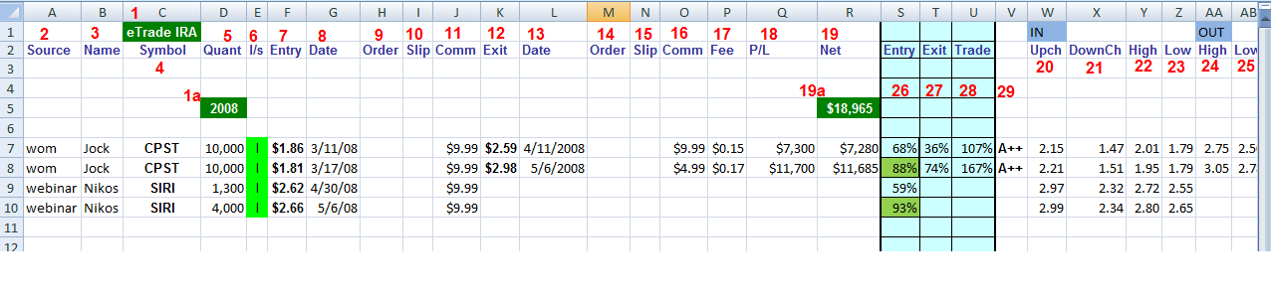
- Account name – I have a separate tab for every account in my spreadsheet. You can use basic Excel commands to create additional tabs and copy-paste this spreadsheet into each of them. 1a refers to the year - as the spreadsheet gets longer, I add new years to it.
- Source - I have several sources for my picks, from the hardest (homework!) to the relatively easier ones, such as tips (wom or word of mouth), webinars, and Spike group. I like to track my profitability from each of these sources.
- Name - I want to record the specific name within each source. I have noticed long ago that I almost always lose money when I follow the trading ideas of some people. This record helps me discover the best and the worst sources of ideas within each group.
- Symbol - the ticker for a stock, future, or option
- Quantity - the number of shares or contracts
- Long/short - the cells in this column turn green when you type letter "l" for long or red when you type "s" for short
- Entry - the price at which your order was filled
- Date - the date your order was filled
- Order - if you used a limit order, leave this cell blank. If you used a market order, type in the price at the moment you placed your order
- Slip - if the previous cell was filled, this will calculate your slippage, either positive or negative, during the entry
- Comm - commission for buying (or selling short)
- Exit - the price at which your order was filled
- Date - the date your order was filled
- Order - if you used a limit order, leave this cell blank. If you used a market order, type in the price at the moment you placed your order
- Slip - if the previous cell was filled, this will calculate your slippage during the exit
- Comm - commission for selling (or covering)
- Fee - exchange fees
- P/L - gross profit or loss per trade
- Net - profit or loss per trade, after commissions and fees (19a shows the net P/L for the year. You can create similar summary cells for other items, such as profit per source)
- Upch - the upper channel on the daily chart on the entry day (fill in manually)
- DownCh - the lower channel on the daily chart on the entry day
- High - the high of the entry day
- Low - the low of the entry day (to calculate entry grade)
- High - the high of the exit day
- Low - the low of the exit day (to calculate exit grade)
- Entry - entry grade (calculated automatically)
- Exit - exit grade
- Trade - trade grade
- an optional grade column (manual) - >30% is A, >20% is B, >10% is C

Copyright 2008 – 2014 www.elder.com

